

BCP Watchdog

Soap Processor Recovery Tool

Version 4.1

(document for internal use only)

Introduction

Reality in life is: programs might crash. Even in normal environments.
In the BCP environment, SOAP processors are the executables to keep your applications interconnected. They should be available all the time. By configuring multiple processors per node, high availability can be achieved. In the event of a SOAP processor crash, the remaining processor(s) take care of handling the load. Meanwhile, the crash should be detected, and a restart should be executed. Here, the BCP Watchdog will do it’s job. The BCP Watchdog monitors all running SOAP processors on all hosts, and takes care of handling any required restart.

BCP Watchdog even goes further. In case of Baan Connectors, it will check the underlying Baan processes if they are still available, and execute a restart if necessary.
In case you have a (scheduled) restart of your Baan system(s), the above will also help you, and there is no need to manually restart the Baan Connectors.
For ODBC/JDBC connectors to databases, a similar check will be executed to see if the DMBS still is available.

Installation

The BCP Watchdog will be running as a SOAP processor. The installation therefor consists of configuring an Application Connector and a new Soap Node. In addition, some java class files, one html file and one dll are to be loaded.

The BCP Watchdog shall be running under the system organisation.

Prerequisites
- In case of using Baan Connectors, it is assumed at least one of the connectors is an update connector. Ensure you have included the ‘http://schemas.cordys.com/CBAC1.2Admin’ namespace at the Baan SOAP Node.

Install the watchdog.jar file
- Copy the watchdog.jar in a folder and include the jar in your classpath (to make the new classpath actual, a restart of your system might be required)
- Copy the watchdog.htm file to {installation folder}\Cordys\Web\wcp\admin\applicationconnector:

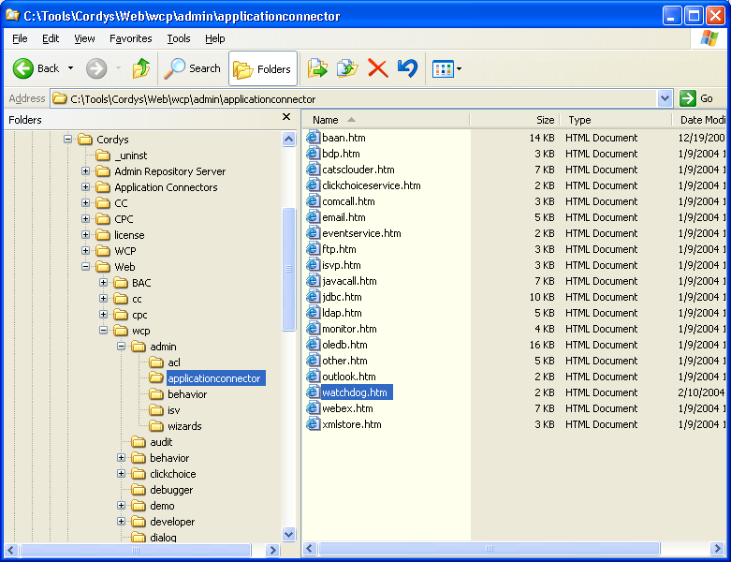

Configure an Application Connector
- Enable ‘developer’ role for ‘system’ user under the system organisation
- Select Organizational Content/Application Connectors
- Right-click ‘New’
- Enter and save with next data:

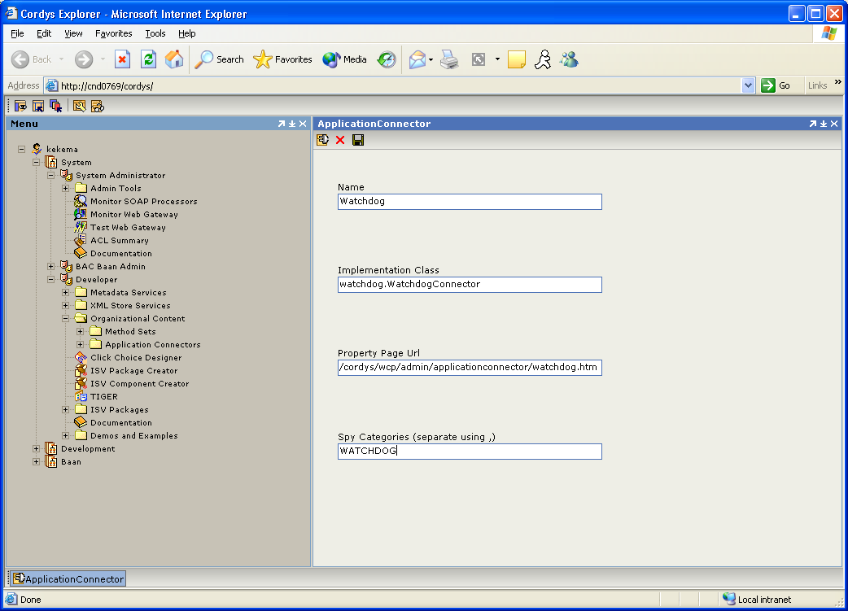

Under the system organization, create a new SOAP node
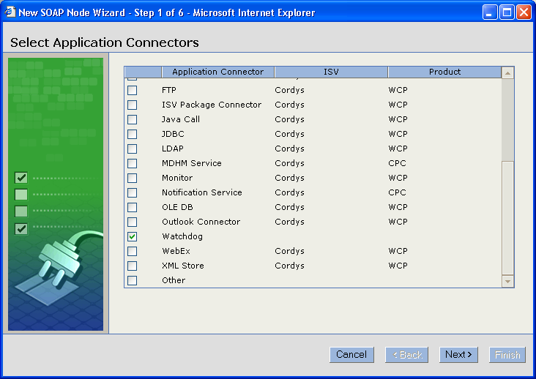

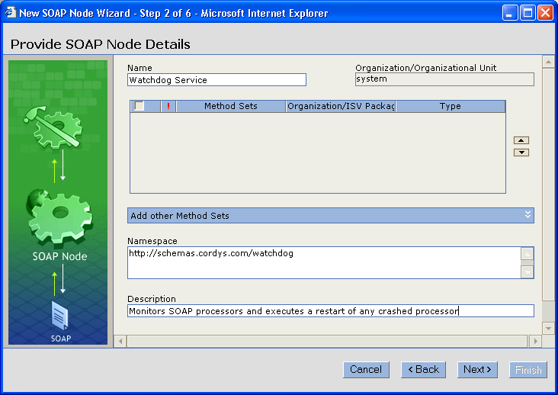
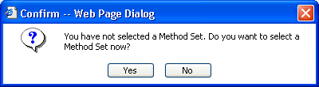

Click ‘No’.

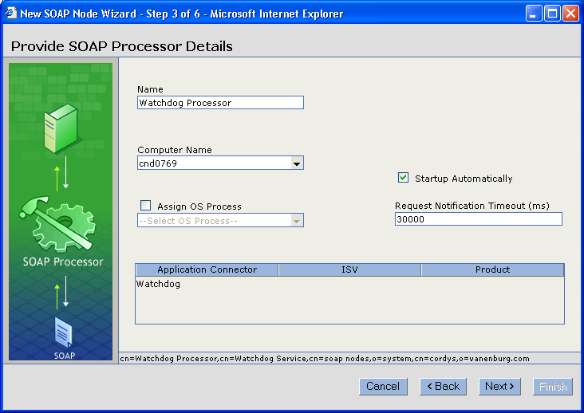

The BCP Watchdog will poll SOAP processors every X minutes for there status. Enter this interval, for example 10 minutes. It is adviced to enter an interval not less than 5 minutes as to keep the network load limited.
When a restart is not successful, you can configure the Watchdog to execute a number of retries. In case all retries do not succeed in restarting the soap processor, you can let the tool send you an email alert. In case no mail profile is present in LDAP, a profile is created with default values.

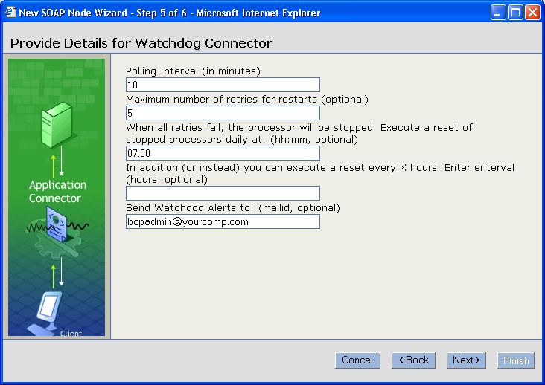

When you don’t specify a max retry, Watchdog will keep trying to restart the SOAP processor in every polling cycle.

As to enable sending email alerts, there should be a processor active with the cordys email connector.

Click ‘Finish’:

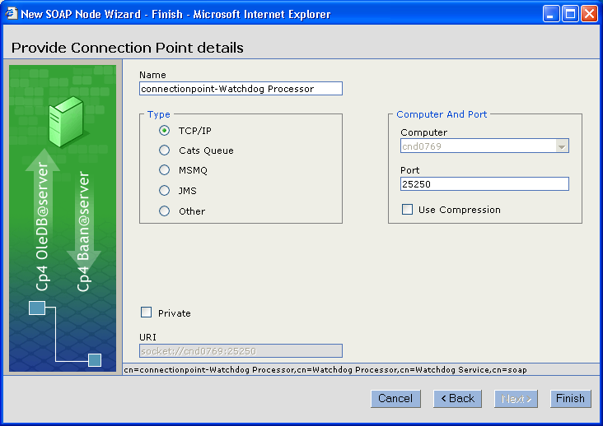
Baan Connectors
In case of using Baan Connectors, ensure:
- the ‘system’ organizational user is having the BAC role.
- in addition, a user mapping should be present to map the ‘system’ user to a Baan user.
The above applies to every organization in which you are running Baan Connectors.

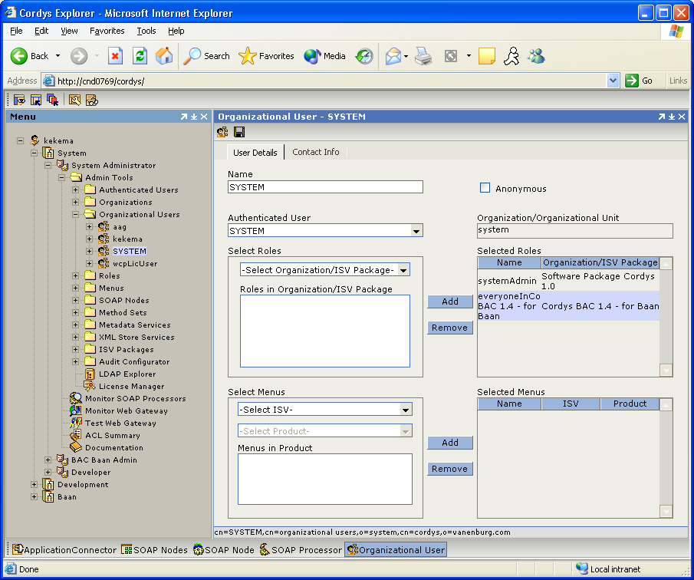

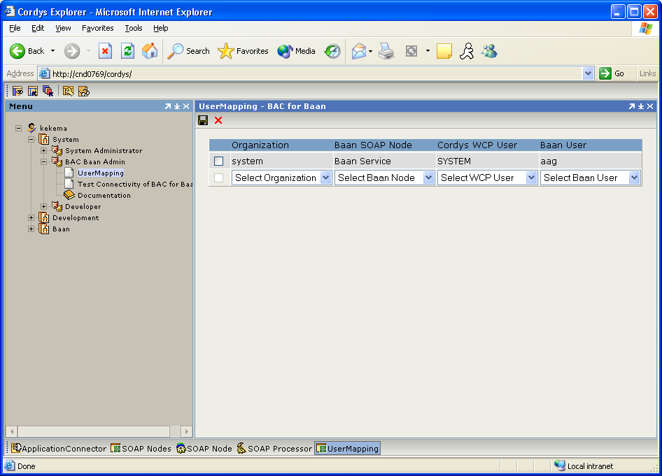
Technical Details
- When the Watchdog is started (by WCP Monitor), it will sleep for 2 minutes as to wait for all SOAP processors to get started.
- The Watchdog will restart any crashed SOAP processors only. So SOAP processors which were never started are left untouched.
- In case Baan Connectors are used, whenever there is a problem with any connector, all Baan Connectors will be restarted. This is related to the fact that problems with Read Connectors can not be detected (repeated reads will give data from cache).
- In case of multiple processors in one process, there will be a one restart for the process
- In case of BAC for Baan 1.3 or below, no automatic restart will be possible, about which the cordys bcp administrator will get notified by email
- In case of a reset (as per reset time, reset interval), all stopped processors will be started again, and again be subjected to the retries.
- In case Event Logging to File is enabled, information messages on steps in the Watchdog will be written to the WATCHDOG categorie.
- Checking the DBMS happens by sending a GetTables method with a non-existing table – this is sufficient to check the DBMS and prevents dataflow-overhead
- When a processor is hanging in ‘Starting’ status for 2 subsequent polls, a restart will be executed

Logic:

Sleep(2 minutes)
While true
Ldap.getAllOrganizations()
For each Organization
Ldap.getSoapProcessors()
For each SoapProcessor
If SoapProcessor is a Cordys Monitor
Monitor.getListOfSoapProcessors()
For each SoapProcessor
If processorStatus = Started
If processor has a Baan connector
Organizational Context = BAC Organization
BAC.getBaanServerInfo()
BAC.getUsersList()
If any issue
BaanProblem=true
Endif
Restore Organization Context
Endif
If processor has an ODBC/JDBC connector
Organisational Context = DBConnector Organization
DB.GetTables(“AAAAA%);
Restore Organization Context
Endif
Endfor
Monitor.getListOfSoapProcessors()
For each SoapProcessor
If SoapProcessor.status = Stopped
Restart=true
Else
If SoapProcessor = BaanConnector and BaanProblem
Restart=true
Endif
Endif
If Restart
If not MaxRetry
Monitor.restart (Processor)
Else
Monitor.stop(Processor)
Send Email Alert
Endif
Endif
Endfor
Endif
Endfor
Endfor
Sleep(PollingInterval/RetryInterval)
endwhile

Standalone run

The BCP Watchdog can also be run from the command line. In this case it will not run as a SOAP processor, but plainly in a JavaVM.

In the rare event of any issue with the LDAP server or the BCP Monitor, the standalone edition of the Watchdog will automatically execute a restart.

As the SOAP processor properties (polling interval, max retry, logging file, etc) are not available in this senario, they need to be specified on the command line.
In below example, all relevant parameters are given with example values.

java -DPOLLINGINTERVAL=10 -DMAXRETRY=6 -DRETRYINTERVAL=70
-DRESETTIME=7:00 -DRESETINTERVAL=6 -DMAILID=bcpadmin@yourcomp.com
-DSPYFILE=c:\watchdog.txt watchdog/WatchProcessors

